**Data Engineering End-To-End (Not Including Vizualization)**

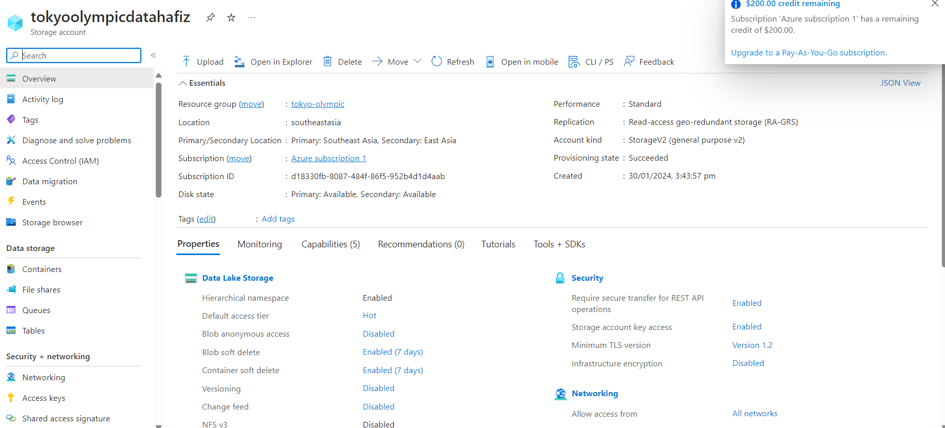

Create Storage account

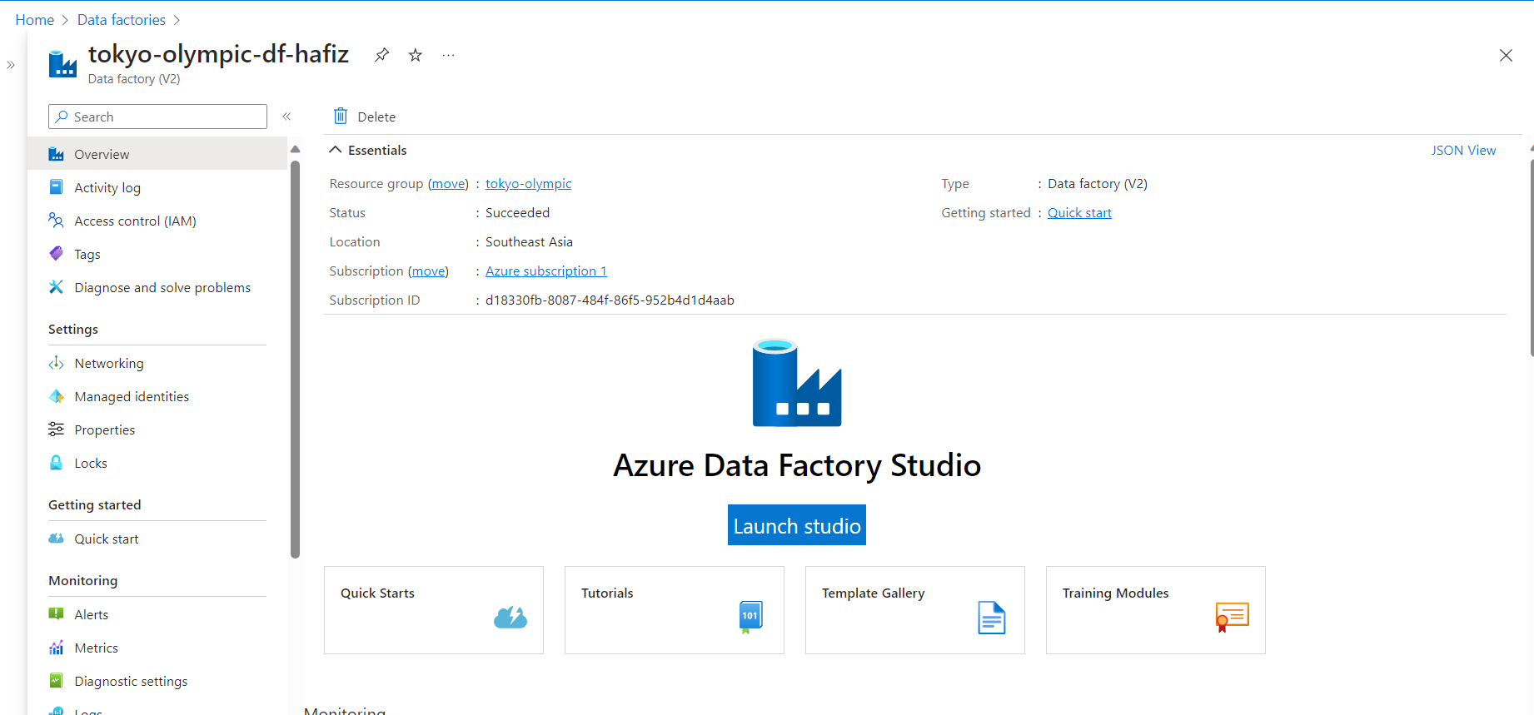

Create data factory account

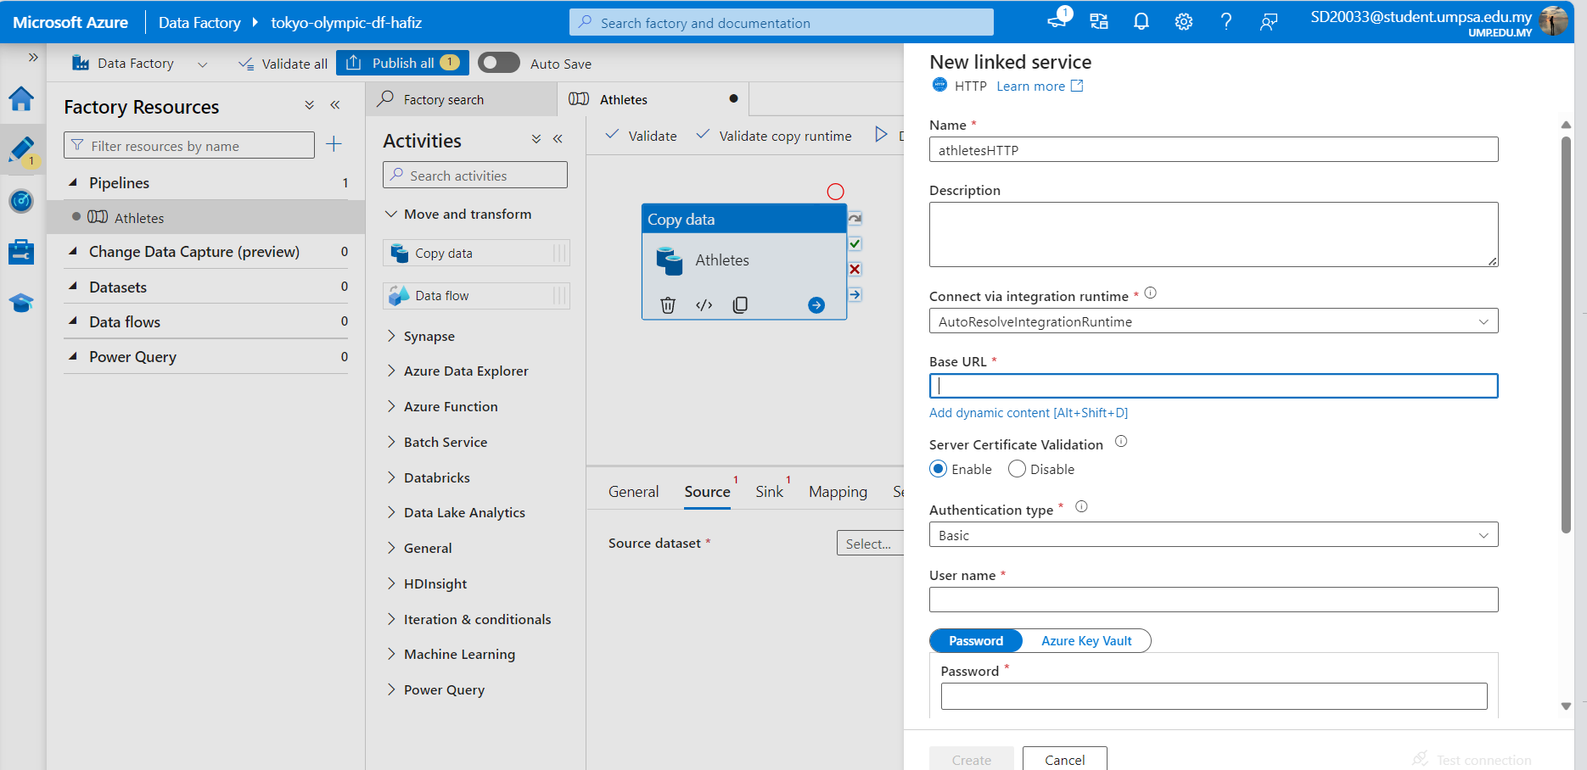

Create Pipeline by linked the wensite from, github link by perfoming linked service from AzureDataLakeStorage1

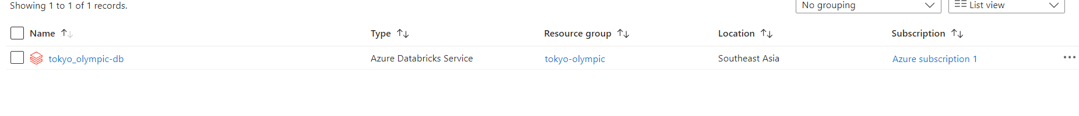

Create databricks account

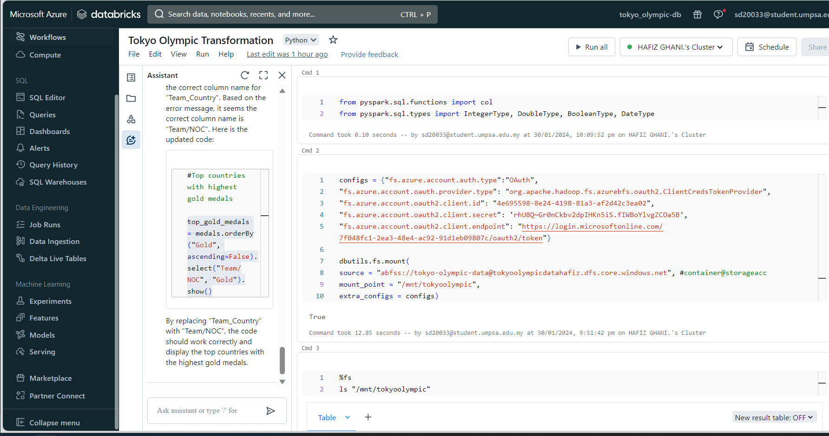

Did data transformation by using databricks. Export it into transformation dataset.

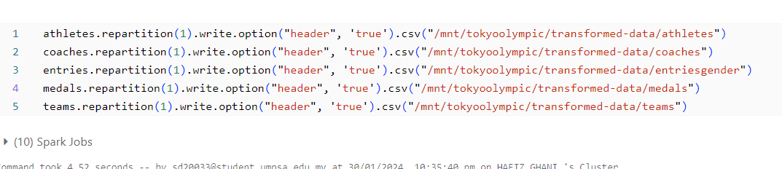

Export data transformed into a new dataset

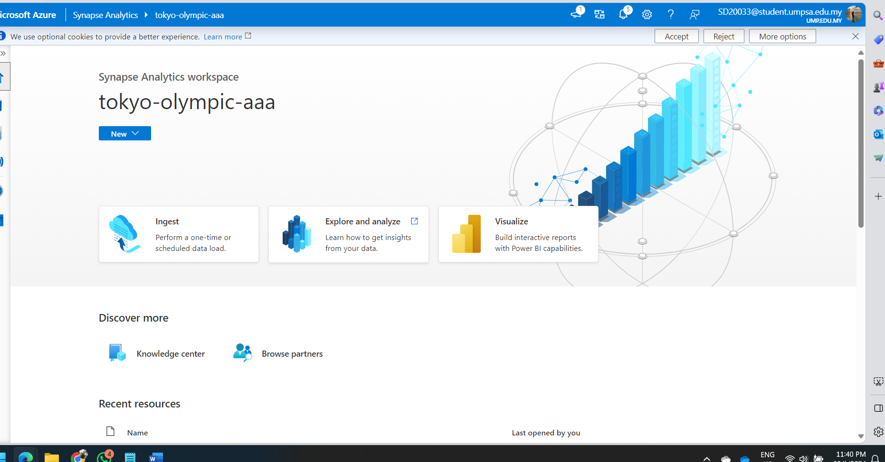

Create Azure synapse analytics

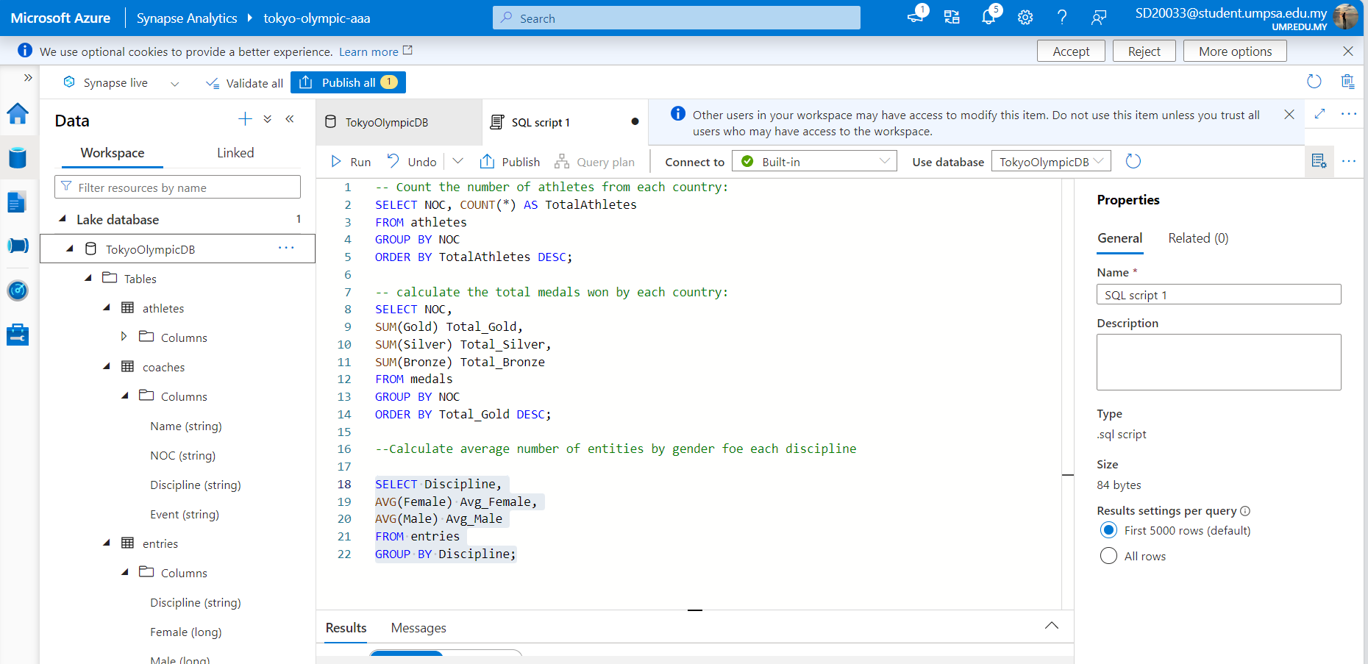

Import dataset, and performed multiple SQL function to display the specific needed.

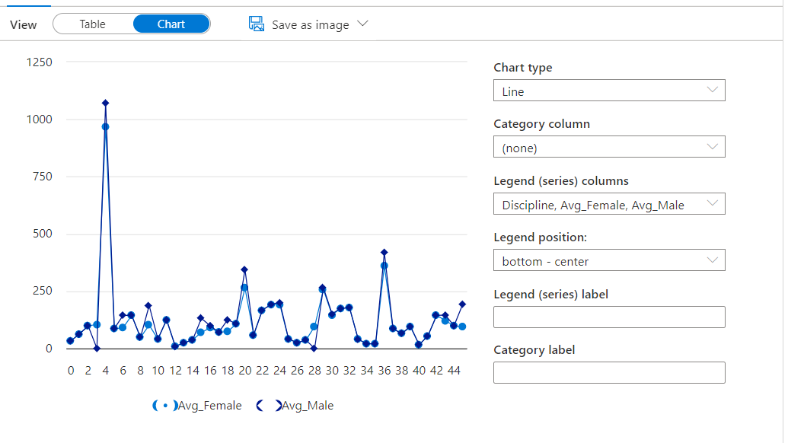

Created data visualization using azure synapse analytics

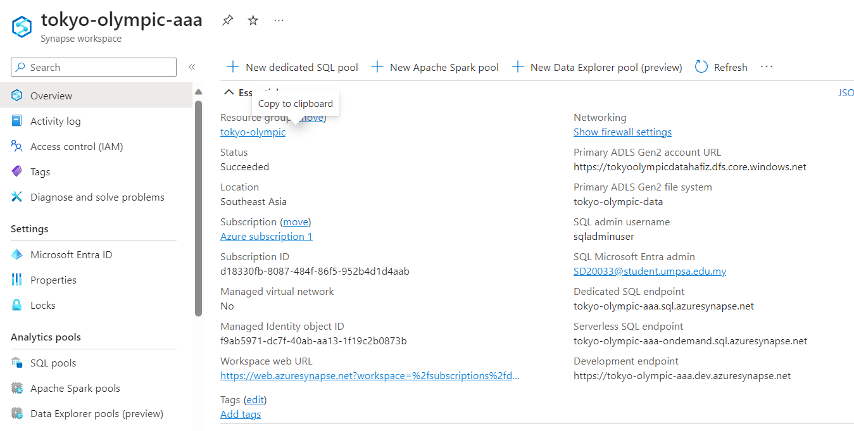

Connect azure synapse analytics to Power Bi to do further visualization

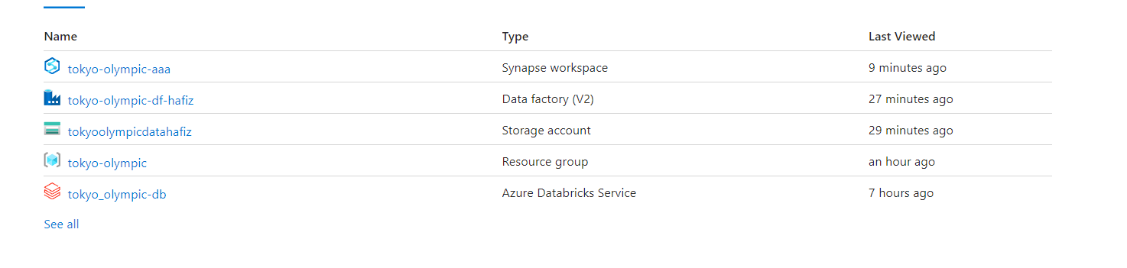

Succefullly creating all services

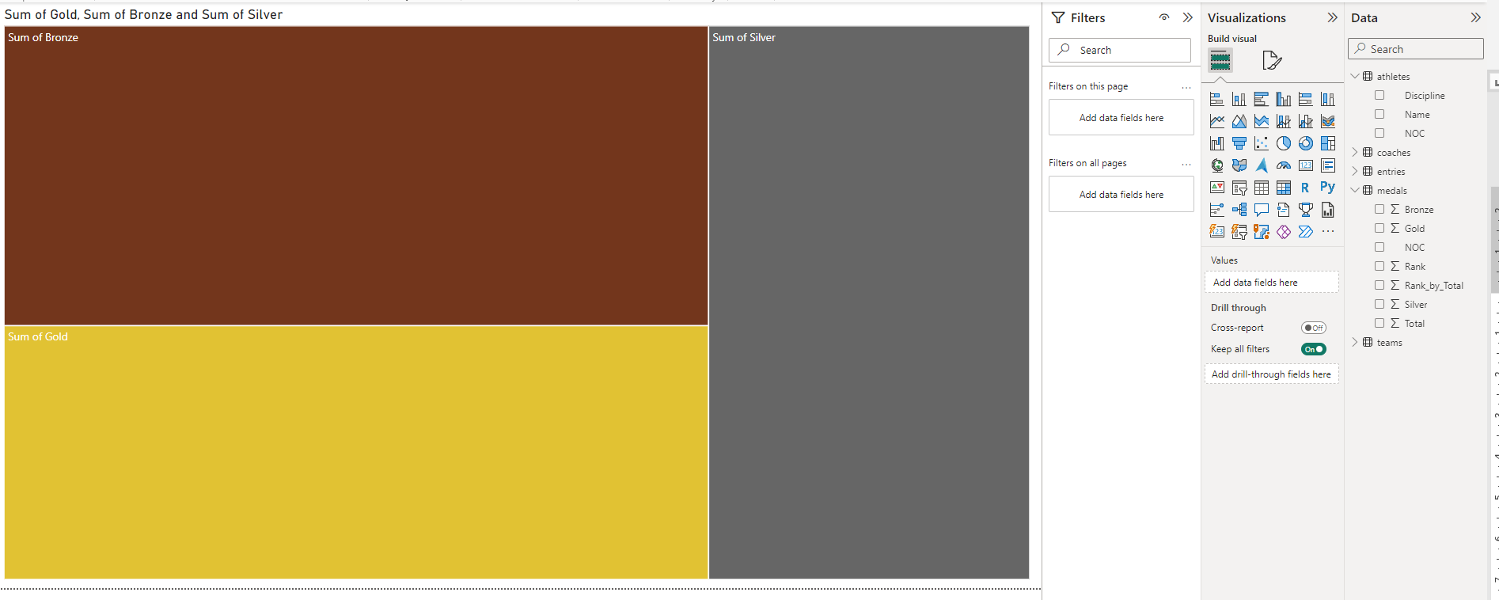

Creating data visualization by using PowerBI